Activities to be performed by GMC MIS EXPERT

GMC MIS EXPERT invoice submission.

Submission of Invoice
      - For invoice Submission GMC MIS EXPERT has to click on “New” button.
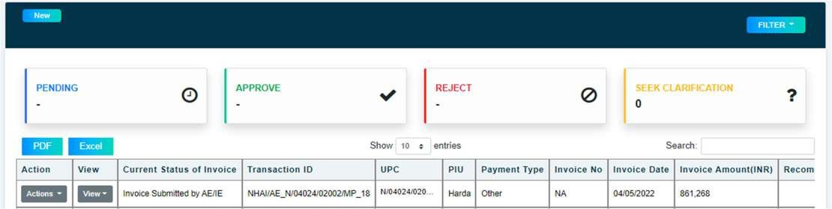

      - On click of “New” button, form will open GMC MIS EXPERT to fill form with required information and upload all mandatory documents.
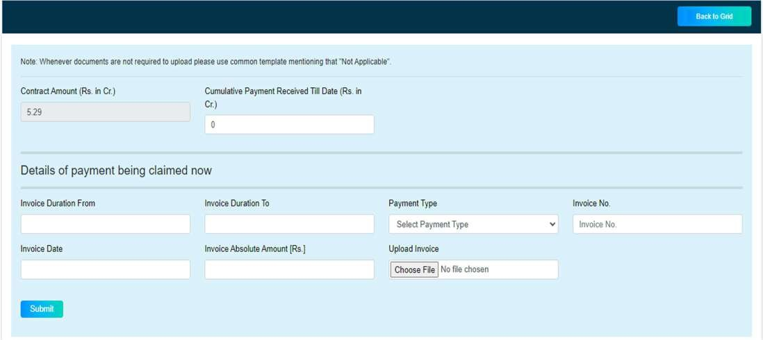

      - After click on submit button, Dairy function will open where GMC MIS EXPERT has to add note using digital signature and upload any other reference document (For Digital Signature Refer Annexure 1).
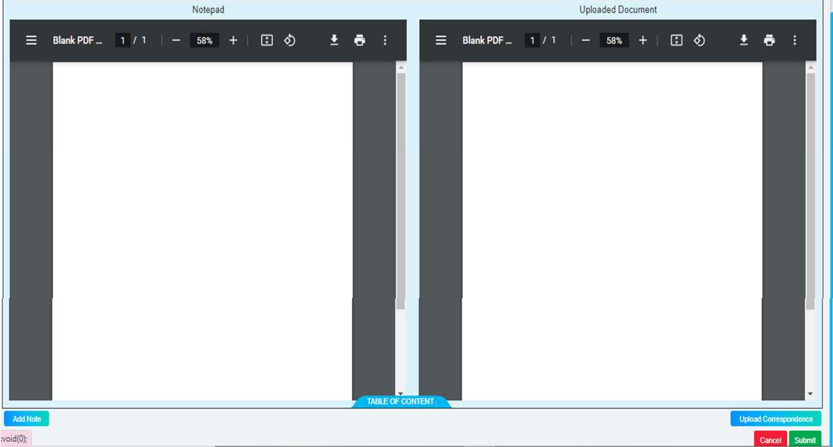

View Submission & Activity Log
      - After Submission of invoice, the invoice gets populated in grid and GMC MIS EXPERT can view submission & Activity log by clicking on “View” button.
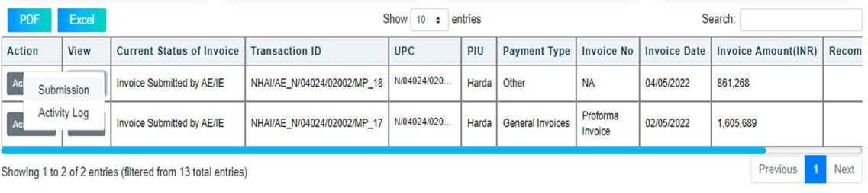

Submit clarification
      - When NHIPMPL HQ seeks clarification from GMC MIS EXPERT on the submitted invoice, “Submit clarification” option appear in GMC MIS EXPERT login.
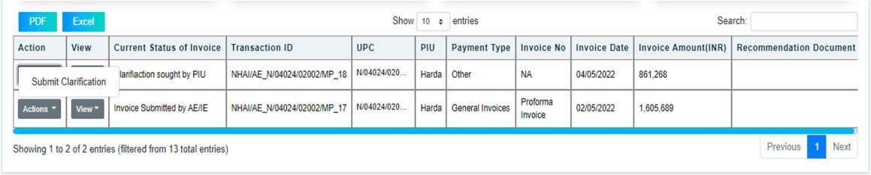

      - On clicking “Submit Clarification” dairy function will open and GMC MIS EXPERT can submit clarification by add note using digital signature and upload document(optional).
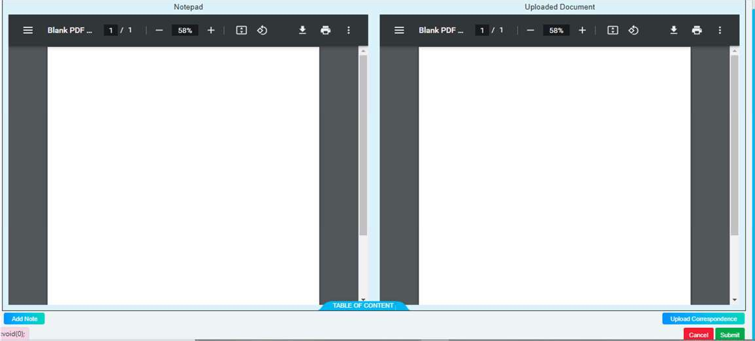

Withdraw Invoice
      - GMC MIS EXPERT can withdraw invoice until NHIPMPL HQ has not performed any action on the submitted claim.
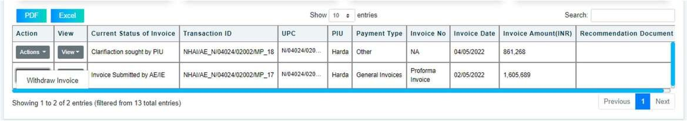

      - On clicking “Withdraw Invoice” dairy function will open and DPR Consultant has to add note using digital signature and upload document(optional).
